

Business Plan

Contact: | David Cornelson
1144 East State St. Suite A
Geneva, IL 60134
Voice: (630) 803-4302
Fax: (630) 206-0678
david@textfyre.com

Table of Contents

1.0 Executive Summary 2
2.0 Company Overview 4
2.1 Mission Statement 4
2.2 Textfyre’s Products 4
2.3 Current and Future Products 5
2.4 Development to Date 5
3.0 Industry Analysis & Trends 6
3.1 History and Background 6
3.2 Industry Size and Composition 6
3.3 Overall Gaming Industry Trends 6
3.4 Sales & Genres 7
4.0 Market Analysis 8
4.1 Parents and Reading-Aged Children 8
4.2 Public & School Libraries 9
4.3 Casual Gamers 9
5.0 Competitive Analysis 10
5.1 Direct Competition 10
5.2 Indirect Competition 10
5.3 Textfyre’s Competitive Strengths 10
6.0 Marketing & Sales Strategy 11
6.1 Roll-Out Strategy 11
6.2 Advertising & Promotional Strategy 11
6.3 Pricing 13
6.4 Sales Strategy 13
7.0 Operations Plan 14
7.1 Location 14
7.2 Contractor Compensation 14
7.3 Suppliers 14
7.4 Customer Returns 14
7.5 R&D Schedule 14
8.0 Management & Organization 15
8.1 Key Personnel 15
8.2 Ownership and Advisors 15
9.0 Future Development 16
10.0 Financials 16
10.1 Sources & Uses of Funds 16
10.2 Financial Analysis 16

1.0 Executive Summary

Textfyre, Inc. was formed as a subchapter S corporation in 2007 by founder David Cornelson. The business is located in Geneva, IL and produces interactive fiction software for the youth market. Interactive fiction combines learning with fun for children, while simultaneously developing reading and cognitive thinking skills.

Interactive fiction has been around since the late 1970s, but lost ground to video games in the mid to late 1980s. Despite the lack of commercial success in recent years, interactive fiction has been sustained by enthusiasts who create and freely distribute their products. With the rise of the educational toy market and the strong youth demographic, Mr. Cornelson saw an opportunity to bring interactive fiction to the market.

Currently, only one competitor commercially sells interactive fiction, Malinche Entertainment. This company has five titles available and targets the adult market with genres including murder mystery, action adventure, and horror. Indirect competitors include video games, books, and other learning software. Textfyre intends to differentiate itself by targeting children between the ages of eight and fourteen, co-packaging their products with complementary products (chapter books, comic books, game cards, etc), and distributing through the web as downloads and online play as well as brick and mortar retail outlets.

Textfyre has chosen two primary targets to market its products – parents and children 8-14 years old and public and educational institutions. Parents will appreciate the educational aspect as well as its non-violent content. Children ages eight to fourteen are in a developmental stage where reading and computers are appealing and necessary for school. Textfyre believes that its entertaining, non-traditional format will be welcomed by both parents and children alike. As a result of this appeal, the nearly 120,000 public and school libraries will be interested in carrying Textfyre’s products. Casual gamers and interactive fiction hobbyists nostalgic for Infocom will be secondary targets.

To reach these markets, Textfyre has developed a roll-out strategy for measured growth. It will first focus on online distribution from its own website before moving to other online retailers as the games gain traction. The company will also seek out retailers, like Wal-Mart, Barnes & Noble and Borders, to sell its software games in their “young reader” sections. Building awareness will be employed through a mix of online advertising and tradeshow attendance.

Textfyre is managed by its founder, David Cornelson. Mr. Cornelson oversees all aspects of the company, especially its game development contractors. Upon launch, Textfyre will be working with advisors to locate a full-time CEO to manage the business. Textfyre has assembled a team of writers, designers, and programmers to assist in game development. These team members are currently contractors, but integral roles will be hired as full-time employees starting in Q4 2008. Financial and sales/marketing professionals will also be sought to round out the management team. The company also has a well-rounded advisory board to assist Mr. Cornelson in strategy development and execution.

To date, Textfyre is near completion of its first interactive fiction product. The product is in the testing phase and planning to be launched in September 2008. A second product has also begun the creation process and will be ready for market by October 2008. Two more products will be be released before the end of the year. The company plans an aggressive product launch schedule with 12 additional titles created in 2009 and 2010. Textfyre is also in negotiations with other prominent fantasy writers for new, branded games that complement their current and future offerings.

This launch strategy promises to be fruitful for the company, with revenues growing from $140,000 in 2008 to $2.75 million in 2010. Profit margins remain strong due to the number of titles available and operational efficiencies.

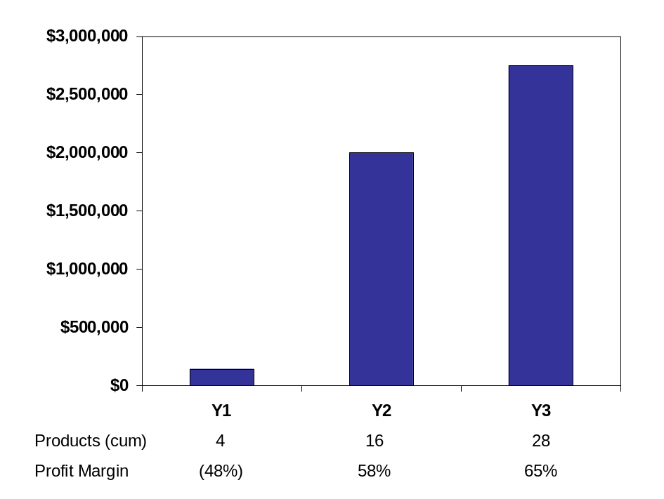

2.0 Company Overview

Textfyre, Inc., was founded in 2006 by David Cornelson and is based in Geneva, IL. Textfyre produces interactive fiction that simultaneously educates and entertains children. Interactive fiction brings books to life with the “reader” or player becoming part of the story and choosing the actions of the main character. This allows for children to develop cognitive thinking skills and increases reading proficiency and comprehension.

The idea for Textfyre was initially born as a hobby of the founder. The interactive fiction industry was popularized in the 1980s, however early companies didn’t adapt to the video game market or were absorbed by video game companies, which didn’t see a value in continuing to publish high quality interactive fiction. The medium was quietly maintained by hobbyists who developed their own games and shared them freely with other enthusiasts over Usenet and later the Internet. As the educational toy market and youth demographic continues to grow, Mr. Cornelson sees an opportunity to bring interactive fiction back to the market.

2.1 Mission Statement
Textfyre will be a parent’s ally in the effort to educate their children. Textfyre’s goal is to have the highest quality yet entertaining interactive fiction on the market. The company aims to combine talent, creativity, and business acumen to sustain success and growth.

2.2 Textfyre’s Products
Textfyre will be a publisher of interactive fiction. Interactive fiction combines the graphics of computer games with the text and storyline of books. The player can see graphics and read along with the story. They are also able to interact with the characters and influence their environment by typing word commands. The character follows these directions and the story changes in response to the player’s commands. This interaction allows the game to be played multiple times without duplication.

Key features of the storybooks include:

- The virtual storybook will consist of basic commands such as: north, south, open door, up and down.
- As the player continues through the story, more complex sentences create more interactivity for the player, such as: climb the north wall or open the gold chest with the silver key.
- Other characters in the story can provide help when asked.
- Players do not have to go page by page in a linear fashion; they have the freedom to move to and from different parts of the story.

Each product will include a full color comic book and/or a card game. Additional offerings may also be packaged with the software as determined by the storyline.

2.3 Current and Future Products
Textfyre’s first product is a part of the Miradania Series called “Jack Toresal and The Secret Letter.” This offering involves a young female character, Jacqueline “Jack” Toresal. Jack is a fourteen year old orphan with an education paid for by an anonymous sponsor living in a fantasy kingdom. She decides to seek out her benefactor in disguise as a boy and eventually finds she is the heir to the local lands and may be eligible for the Kingdom throne. This storyline offers adventure in a fantasy world by a character close in age to the target market.

The Miradania Series continues with “Jack Toresal and the Trial of the Vedd” and finishes with an untitled third game in 2009.

To date, three more series are in various stages of development:

- The second series, Klockwerk, begins with “The Shadow in the Cathedral” published in 2008 followed by two more titles in 2009.

- The third series, Giant Leaps, begins with an untitled game published in 2008 with two more games in 2009.

- The fourth series is currently being discussed by the game designer and writer and is estimated to be published in 2009.

Textfyre is working with a well-known fantasy author, Janny Wurts, to develop with three games in the world of Athera, part of her War of Light and Shadow series of books. The first of these would be published in 2009.

2.4 Development to Date
Textfyre is currently in the start-up phase of development. To date, the following tasks have been completed or are in development:

- $9,500, three year loan has been secured
- All necessary paperwork has been filed with the city and state
- Key illustrators and programmers have been contracted
- First interactive fiction product will be published in June of 2008
- Subsequent games will be published in August, October, and December of 2008
- In 2009 and going forward, Textfyre will publish at least one game per month
- Character and title trademarks will be sought as games are published

3.0 Industry Analysis & Trends

3.1 History and Background
Interactive fiction was originally developed by Will Crowther in 1975 with the simple game Adventure. Don Woods of the Stanford Artificial Intelligence Laboratory re-envisioned Adventure with more advanced technology and an expanded storyline in 1977. Both versions of the game ignited interest in interactive fiction and led to its widespread success in the 1980s.

Infocom was the largest company to produce interactive fiction and released a number of very popular titles before being acquired in 1986 by Activision, a well known computer and video game company. The rise of video games in the late 1980s put many of the interactive fiction producers out of business as players responded to the enhanced graphics, sounds, and technological capabilities.

Interactive fiction made a brief resurgence in the 1990s by incorporating many of the characteristics of video games, but was never able to gain significant traction or market share. All notable entrants were purchased by video game companies and incorporated into their gaming portfolio.

3.2 Industry Size and Composition
The interactive fiction industry has become a small niche market with very few producers and competitors. As mentioned earlier, most of the industry is self-produced and informally distributed for free by interactive fiction enthusiasts. Industry insiders estimate that up to thousands of new games have been developed since the birth of interactive fiction. Despite the lack of commercial support, the availability of high quality tools and competitions allow enthusiasts to develop new, high quality games.

3.3 Overall Gaming Industry Trends
According to The NPD Group and the Entertainment Software Association, the gaming industry nearly tripled from $2.6 billion in 1996 to $7.4 billion in 2006. The industry appears to be maturing, leveling off at $7 billion in annual sales in recent years.

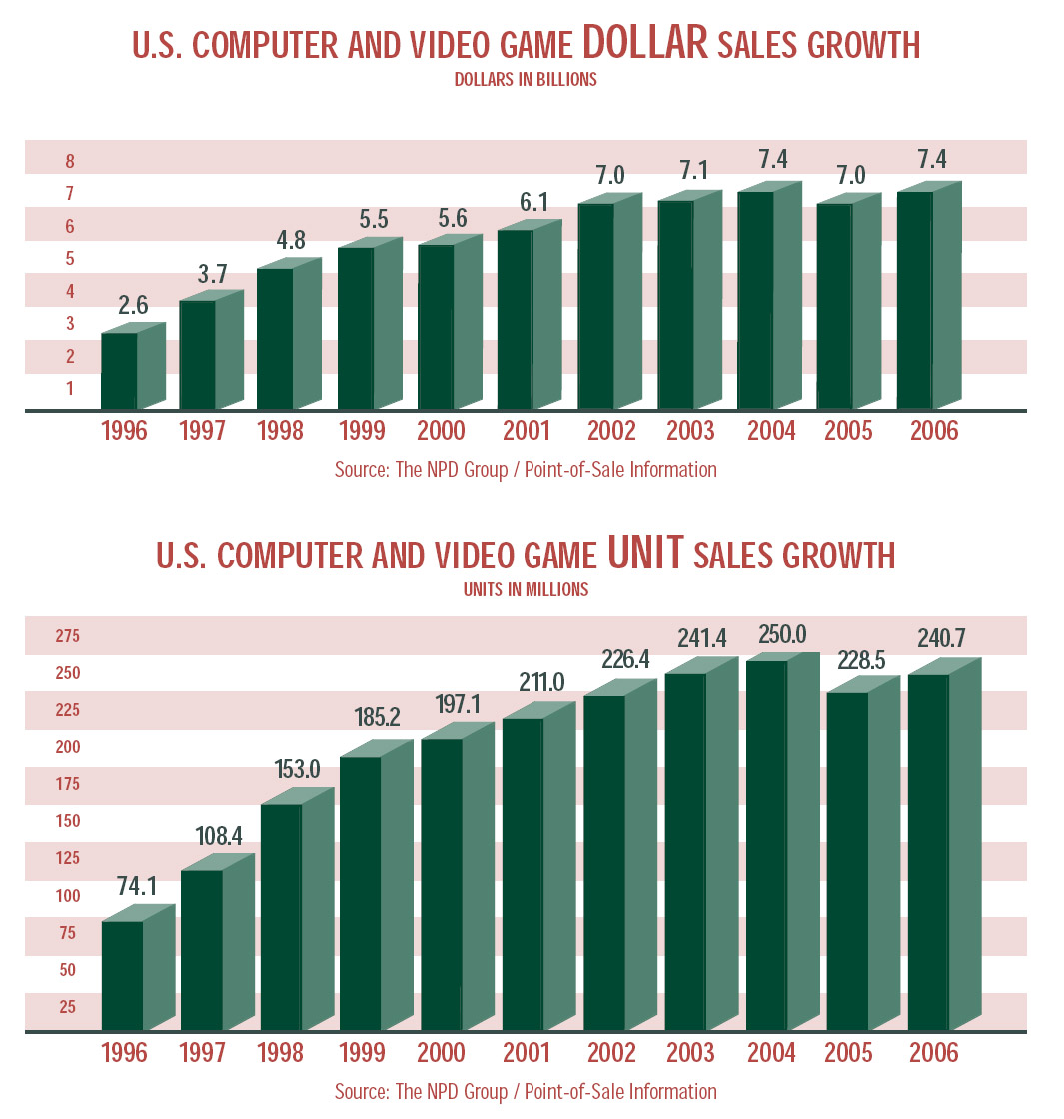

Similarly, unit sales have stayed above 225 billion games sold annually since 2002.

3.4 Sales & Genres
The Entertainment Software Association and NPD also reports that:

- Ratings – 85% of all games sold in 2006 were rated “E” for everyone, “T” for teen, or “E10+” for everyone over 10 years old. The remaining 15% of games sold were rated “M” for mature audiences.
- Video Games – 27.5% of games sold were action oriented, 17% were sports related, and family entertainment, role playing, shooter, and racing each comprised 10% of industry sales. Adventure games comprise 3.4% of the video game market.
- Computer Games – 35% of games sold were strategy, 14% were role playing, 13% were family entertainment, and 11% were shooter games. Adventure games comprise 5.7% of the computer game market.

Interactive fiction is often considered to be an adventure game and would be rated “E” for everyone. Adventure games are a type of computer entertainment program that are interactive and based on a storyline. These games follow the same story conventions as literature or film. Adventure games include genres such as: fantasy, science fiction, mystery, horror, and comedy.

4.0 Market Analysis

Textfyre will have several distinct target markets including; parents and reading-aged children, public and schools libraries, casual gamers, and those nostalgic for the old Infocom products. Parents, children, and libraries are the primary target.

4.1 Parents and Reading-Aged Children
The company will target primary or middle school children between the ages of 8 and 14 years old who enjoy reading and are computer literate. Primary school students (K-4th grade) are at a developmental age where they are naturally inquisitive and are interested in reading as a hobby. They are also old enough to have had exposure to the computer and its basic functions. Middle school children (5th-8th grade) read primarily to meet school demands, but have increasing interest in video games and technology. Textfyre appeals to the desires of both primary and middle school children by providing an offering that meets both their needs. Publisher’s Weekly has reported that this demographic has from $50 to $100 per month in disposable income and casual reading has increased in recent years.

US Census population estimate of the target market:

Ages 5-9 | 19,539,000
Ages 10-14 | 20,858,000
Total | 40,397,000

Textfyre’s computerized text adventures will likely have more female than male buyers. Research has concluded that girls will be more open to interactive fiction and adventure storylines and it combines their interest in reading and computers. The International Reading Association found:

- Girls read more than boys; 39% of boys found reading to be boring
- Boys tend to resist reading stories about girls
- Girls do not tend to resist reading stories about boys
- Boys read less fiction than girls; preferring graphic novels and comic books
- Boys tend to be more interested in video/computer games

Parents will also be a secondary target. Parents want their children to develop the necessary skills for advancement, many of which coincide with the games’ features. This includes reading comprehension and skill advancement, problem solving, critical thinking, and creativity. These games will also be non-violent which is rare in the computer/video/book market. Parents, more than ever, are looking for games for their kids that are not violent. Research has shown that video game violence has been shown to increase the chance of violent behavior in kids.
The combination of a technologically advanced storybook with excellent, non-violent computer graphics will appeal to parents and young consumers. These games will be educational, not because consumers will have to solve math questions to move forward, but because the games will teach young consumers basic computer and reading skills. This appeal will make household buying decisions easier as there will no longer be arguments about which games the child wants versus what the parent wants.

4.2 Public & School Libraries
Textfyre will also target both school and public libraries as an electronic offering for children.
According to a report by the National Center for Education Statistics, there are 16,543 public libraries in the US in 2005. These libraries saw 1.4 billion visits in 2005 or 4.7 library visits per capita. There are 2.1 billion materials in circulation, 35% of which is for children.

The National Center for Education Statistics also released a report on public and private school libraries for the 1999-2000 academic year. It reported that there were nearly 84,000 public schools serving 45 millions students. 77,000 (92%) of the 84,000 had school libraries. Almost all of these public school libraries had a library media center, defined as an organized collection of printed, audiovisual, and/or computer resources.

The report also indicated there were over 27,000 private schools serving nearly 6.2 million students. 17,000 (63%) of the total have library media centers.

With approximately 120,000 libraries, Textfyre believes this is a large and receptive market for interactive fiction due to its educational benefits.

4.3 Casual Gamers
Casual Gamers play games across a variety of genres, complexity, and difficulty. They approach gaming as a hobby and look for games that are easily accessible (usually online) and user friendly. The Casual Gamer market has begun growing steadily, with the Casual Games Association claiming a 20% increase in sales per year and a current $2.5 billion industry.

This indicates a large portion of Americans have begun using games on a casual basis but do not consider themselves “gamers.” The Casual Gamer Association notes that the casual gaming market is often underestimated and thought to be a smaller portion of the major gaming audience. The association found just the opposite, almost everyone in the country plays casual games, with the most popular games being Solitaire and Tetris.

Ran Cohen of Eyeblaster, an in-game ad firm, says that “the whole industry of the downloadable casual game is female-oriented.” He noted that 60%-70% of casual game players are females over 30.

4.4 Nostalgic Infocom Customers
Infocom was the largest, most advanced, and highest quality interactive fiction developer throughout most of the 1980s. Infocom’s success is attributed to its marketing strategy, rich storytelling and imaginative props and extras that accompanied the games. It had a wide variety of titles that spanned across genre and gender lines. Textfyre believes that the original interactive fiction players, many of which who are still active in the hobby market, will purchase its products out of nostalgia and curiosity.

5.0 Competitive Analysis

5.1 Direct Competition
There is currently only one direct competitor in the commercial interactive fiction market. Malinche Entertainment was founded in 2002 and has sold over 100,000 copies of its first three titles. Currently, the company offers four titles for consumers with its fifth released earlier this year. Malinche carries titles in genres such as murder mysteries, action adventure, and horror. All titles currently appear to be aimed at an adult target market

All titles are offered in disc, PDA, cell phone, and iPod formats which range in price from $9.95 to $34.95. An individual can download a smaller, more condensed version of the storyline to their iPod for $9.95. For $24.95, the consumer can receive a full version of the title over E-Mail download, which also comes with the ability to be placed on specific cell phones and PDAs. Finally, the $34.95 option includes the delivery of a disc copy of the game along with related paraphernalia.

5.2 Indirect Competition
Further research of the market yielded three industries that would be indirect competitors. Video games, traditional books and interactive learning software all show significant competition for the company.

Video games have become extremely popular among a very wide age group. Since their introduction video games have continued to evolve at a fairly quick rate; leading consoles such as XBOX and Playstation are continually pushing the limits on their equipment to give the user interactive experiences that surpass those of its competitors.

Traditional books have withstood the test of time and have been a source of entertainment for ages. In this area, Textfyre offers consumers a product that is not mainstream. Many children have never heard of interactive fiction which gives the company an opportunity to renew interest in reading and help the product grow.

Learning software is a very common purchase for parents for their children. Because interactive fiction involves reading, parents may recognize its ability to improve reading skills in their young children. The popularity of all these products among consumers is already very high but Textfyre has advantages in the marketplace that give it a jump-start in front of its direct competition.

5.3 Textfyre’s Competitive Strengths
The strengths listed below may allow Textfyre to successfully compete in the market place:
- Significantly younger target market than its direct competitor. By reaching this market the company will be able to establish a new consumer base which it can expand off of.
- First interactive fiction novels to be accompanied by graphic art throughout the story line.
- Retail distribution strategy. Availability at store locations can help raise awareness to those consumers who are not yet familiar with interactive fiction as well as give those who do not like to purchase over the Internet the opportunity to buy.

6.0 Marketing & Sales Strategy

Textfyre will focus its marketing efforts on its unique combination of education and entertainment in a convenient location at an affordable price within its niche segment. Marketing and sales will be targeted to children, parents, casual gamers, and old Infocom customers through a variety of marketing tactics.

6.1 Roll-Out Strategy
Textfyre will initially sell their games through the company’s online store. After six to twelve months, Textfyre will expand its product distribution by discounting the games for purchase through popular internet outlet stores such as Amazon.com. As the company’s sales grow online, Textfyre intends to distribute and sell the software at retail bookstores, such as Barnes & Noble and Borders. The software will be displayed in the “Young Reader” section of the bookstore, where it will best reach its target market.

6.2 Advertising & Promotional Strategy
The marketing strategy will be implemented via a number of methods and channels based on market and demographic research. The advertising strategy will focus on three key areas:

- Online advertising
- Print advertising
- Cooperative advertising campaigns with both online and conventional retailers
- Tradeshows and school events
- Public relations

Online Advertising
Internet advertising has multiple advantages that are attractive to Textfyre. It is relatively low cost yet has immediate placement, and therefore is very suitable for Textfyre’s limited advertising budget. In addition to the low cost, internet advertising provides vast marketing exposure. Millions of people use the internet to search for products, thus allowing Textfyre to penetrate other markets at a fraction of the cost of traditional advertising methods. Advertising on the internet does not only reach the ideal target market, it reaches and informs other potential consumer markets as well. Textfyre will be able to reach millions of potential customers and position the company for success, without the need for a costly infrastructure and overwhelming marketing costs.

All online ads will refer the consumer to Textfyre’s website and allow the consumer to learn the benefits and features of the products. Consumers will also be able to post user reviews and ratings of the software. This will help Textfyre effectively heighten brand awareness for new products while strengthening customer relations.

Advertising online also allows Textfyre to measure its marketing success as well as capture valuable data about its current and potential customers. Textfyre can use internet tools that provide real time statistics, on unique visitors, repeat visitors, and click through rates on advertisements. This provides them with important details about their web visitors and advertisements, allowing them to evaluate the effectiveness of each marketing campaign. This allows them to determine what programs work for their particular market and make any changes in their marketing strategies.

Print Advertising
Textfyre will purchase print ads targeting the homeschool and library markets. Homeschool.com has a print newsletter that is distributed to 50,000 recipients as well as having a website that draws 3 million visitors per year. The company plans to sponsor the monthly newsletter as well as purchase monthly banner space on their website. It will also purchase print ads in magazines that are frequently purchased by libraries.

Cooperative Advertising
In addition to Textfyre’s online advertising, Textfyre will engage in cooperative advertising with retailers. This will include marketing campaigns with online retailers, such as Amazon.com, and conventional retail stores, such as Barnes & Noble and Borders.

Amazon.com
Amazon provides the business, marketing and vendor support necessary to maximize sales. Amazon allows vendors to control the content on their product detail page, but also offer professional assistance to help the vendor best market and emphasize their product features. This will be quite beneficial to Textfyre. Considering Amazon’s marketing suggestions, Textfyre would include in depth descriptions and product reviews. Textfyre would also upload screen shot animations and short video clips from the software. This would give the consumer insight into what the game looks like and how it actually functions. Amazon also provides vendors with a variety of marketing features to help increase product placement and exposure. Amazon’s auto-merchandising program will proactively display and market Textfyre’s products to potential customers.

This personalization technology helps customers navigate the site to not only find the products they are looking for, but also to discover products they did not know existed. This is extremely beneficial as consumers who may not know about Textfyre’s software will be exposed to it through Amazon’s “personalization” marketing programs. More specifically, Amazon’s personalization technology markets products through their product pairings, such as the “Customers who bought this…also bought this” feature. This suggests similar products to that which the consumer is viewing.

Textfyre would also utilize Amazon’s gold box marketing program and the “new product emails.” The gold box uses Amazon’s personalization technology to suggest, to each Amazon.com customer, ten new products everyday. The new product emails are intended to inform and market new products to Amazon members. These programs level the playing field for Textfyre, because Amazon provides Textfyre with the tools and framework to ensure its software appears frequently and prominently on Amazon.com.

Retail Stores
Textfyre will also participate in cooperative advertising with retail stores. This will include setting up special product displays showcasing Textfyre’s software. These displays will draw attention to Textfyre’s products, increase consumer awareness, and also emphasize the products’ features. Additionally, retailers will include information about Textfyre’s products in their customer mailings. These mailings will include details about and reviews of Textfyre’s software. While these mailings will not reach quite as many potential customers as internet advertising, it will market to consumers that may not be exposed to internet marketing. It also simply provides another low cost medium by which Textfyre can increase product awareness.

Trade Shows
Textfyre will use brochures and printed materials to distribute to potential customers at tradeshows, schools, and libraries. At tradeshows, Textfyre will use its marketing materials to inform others in the book and gaming industries about its software. This will alert others of Textfyre’s presence and help develop valuable contacts in the industry. At schools and libraries, Textfyre will use the marketing materials to reach the target market and make them aware of Textfyre’s new software. Because the market is relatively unfamiliar with Textfyre, this will provide the company with an opportunity to build awareness of interactive fiction.

Public Relations
Press releases will be periodically distributed to parent, educational, and trade publications and popular media outlets. To date, Textfyre has commitments from Wired Magazine and Armchair Arcade to review its games. The company will also contact a resource at the NY Times for reviews as well as other large newspapers and magazines.

6.3 Pricing
The pricing strategy for Textfyre’s product was based in part on the company’s financials and in part on the company’s indirect competition. Since Textfyre’s game is, in a broader category, computer software, its closest competition is believed to be other computer software games. Most of these games are selling in the $20 range, except when downloaded directly from the internet where they are frequently offered at a small discount.

The company decided that titles will be priced in-store at $29.95 and $24.95 over the internet. Downloadable versions will be almost completely profit.

6.4 Sales Strategy
Textfyre’s founder, David Cornelson, will conduct most direct sales activities. Mr. Cornelson will be charged with attending industry events, growing awareness of the interactive fiction market, and acquiring retail distributors. Dennis Jerz, an unpaid advisor, has also committed to helping Textfyre with tradeshows that are related to New Media education.

7.0 Operations Plan

7.1 Location
Textfyre will operate as a virtual business. With an all contractor staff, the company has determined that no physical location is necessary in the short term. The company is headquartered out of the home of the founder, David Cornelson, in Geneva, IL.

As the company grows, a physical office will be sought in Year 2 as employees are hired to meet growing demand.

7.2 Contractor Compensation
Textfyre will not have any employees in the short term, relying on freelance professionals to work on a contract basis. The company has negotiated standard industry payment policies for each contractor, including:

- Writers are paid $.20 per word ($.04/word during production and $.16/word after 5,000 games are sold) and receive no royalties. Games will be roughly 25,000 to 50,000 words
- Programmers are paid a flat fee and receive no royalties
- Game designers are paid standard book author percentages – 10% for the first 5,000 copies sold, 12.5% for the second 5,000 sold, and 15% for all copies sold over 10,000

Contractors will be hired as the company increases game production. The first employees will likely be hired in mid-2008 to meet 2009 game development needs.

7.3 Suppliers
Textfyre is in the process of securing a fulfillment company to provide printing, packaging, inventory, and shipping services. The company anticipates placing orders in increments of 2,000 on an as-needed basis to keep inventory low and costs down. Textfyre has been researching potential vendors and plans to have a contract in place by December, 2007 when the first game will be ready for distribution.

7.4 Customer Returns
All packaged games will eligible for a full refund within seven days of purchase or anytime if the product has retained its original packaging. Downloaded games will be reviewed by management on a case by case basis, based on discussions with the customer.

7.5 R&D Schedule
Currently, it takes 4-6 months to produce each game with the current staff of writers, designers, and programmers. It is estimated that this timeline will be reduced to three months as experience improves and efficiencies arise. To reduce development time, Textfyre plans to use the same staff of contractors as future games are developed.

8.0 Management & Organization

8.1 Key Personnel
David Cornelson, CEO, is an IT consultant of twenty-two years having worked on projects at many Fortune 500 corporations in the healthcare, insurance, financial, and manufacturing industries. Mr. Cornelson will oversee the day-to-day operations of the company and is responsible for developing its strategy and direction. He will ensure all aspects of Textfyre’s operations are efficient, meeting productivity goals, and the proper personnel are in place. He will also oversee all sales efforts, financials, and quality controls for new product development.

Mr. Cornelson is currently running the business part-time, but estimates moving to a full-time role in August of 2008.

The following contractors have made significant contributions to the development of the first and second product offerings.
- Erika Richardson, Graphic design and illustration
- Michael Gentry, Interactive fiction writer and designer
- Jesse McGrew, Systems programmer
- Graeme Jefferis, Inform 7 programmer
- Peter Mattsson, Flash and UI Programmer
- Ian Finley, Interactive fiction writer and designer
- Jon Ingold, Interactive fiction writer and designer
- Paul O’Brian, Interactive fiction writer and designer
- Chris Huang, Interactive fiction writer and designer
- Alexandre Owen Muniz, Interactive fiction writer and designer
- Mike Snyder, Interactive fiction writer and designer

As the company grows, Textfyre anticipates hiring a full-time artist and a writer by August of 2008. It will also hire a full-time programmer and administrative assistant in January of 2009. These employees will be hired to meet the growing demand for game development. The company will also seek a financial manager and a sales and marketing specialist in 2008.

8.2 Ownership and Advisors
David Cornelson has full ownership of Textfyre, Inc., an Illinois subchapter “S” corporation. The Company’s advisors include:
- Jack Cummins, Attorney
- Dr. Bill Kolomyjec, Education expert
- Dr. Dennis Jerz, New media expert
- Dr. Nick Montfort, Interactive fiction expert
- Jeff Tagge, Publishing
- April Lane, Consultant

9.0 Future Development

Textfyre will continue to grow by offering more products, multi-user formats, handheld games, and distribution alternatives. This strategy allows the company to grow at a measured pace and with further market analysis. Some of the developments are:
- Voice-controlled games
- Multi-user games
- Games available in other languages
- Mobile devices
- Tablet PC’s
- Chapter Books
- Educational Material
Textfyre also holds all of the rights to merchandising as well as book publication and movie/TV development.

10.0 Financials

10.1 Sources & Uses of Funds
Textfyre has secured a $9,500 loan payable over three years. This sum is in addition to the owner equity invested by David Cornelson to cover all developmental costs to date as well as launch expenses.

The company is seeking $200,000 to $400,000 in investments to launch the production cycle. This amount will be paid back to the investor within 5 years in addition to residuals tied to revenue.

10.2 Financial Analysis

Textfyre believes that it will be able launch 4 interactive fiction games by the end of 2008, and an additional 12 games each year thereafter. With this product launch schedule, the company will be able to grow quickly by reinvesting its profits while reducing costs through efficiencies.

The company anticipates generating $140,000 in revenue by the end of 2008. This results in a loss due to the high development costs and the hiring of full-time staff. This number grows steadily each year at 1300% in the second year and 37% in the third full year of operations as more interactive fiction games are introduced and the awareness solidifies.

The company is able to reap cost savings in Year 2 through the retention of key contract employees who are integral in the development process. Their experience aids in keeping costs low relative to growth. Operational expenses increase sharply in Year 2 due to an aggressive product launch strategy, but cost increases slow in Year 3 due to efficiencies.
Appendix A

Cover art for Secret Letter:
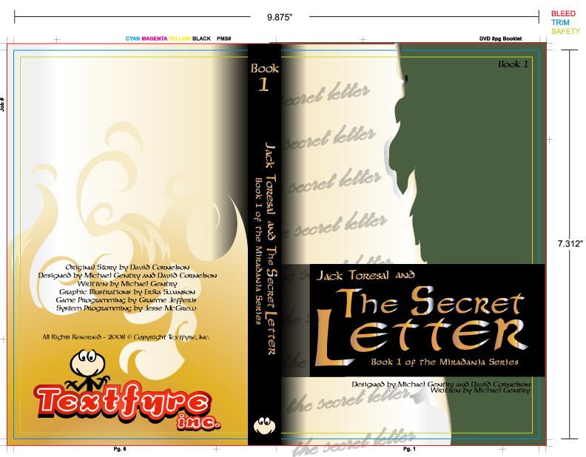



Appendix B
2008 Income Statement

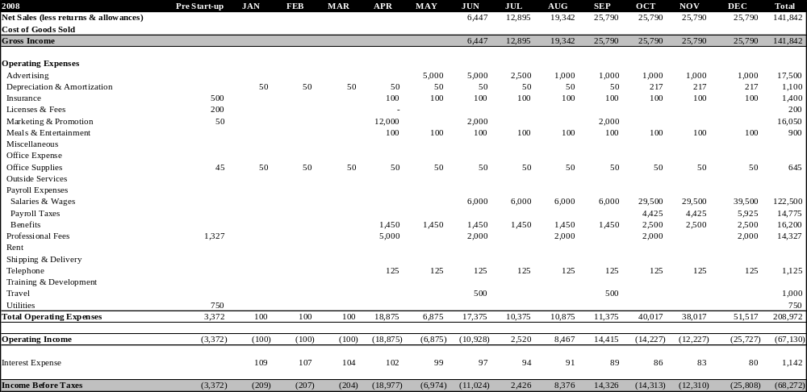
2009 Income Statement

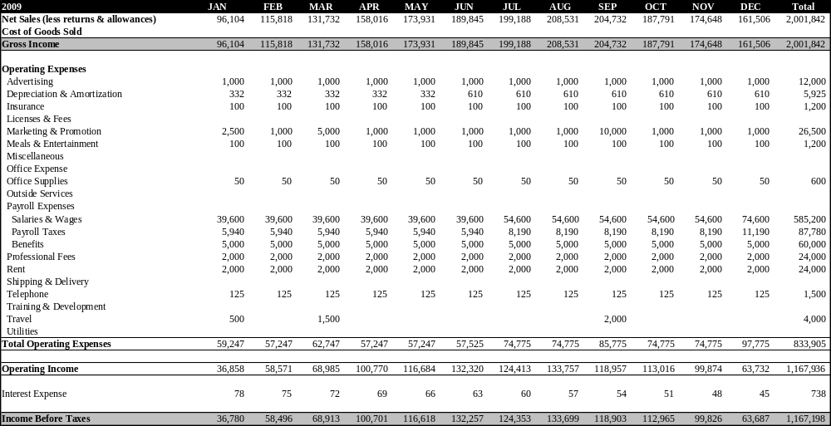

2010 Income Statement

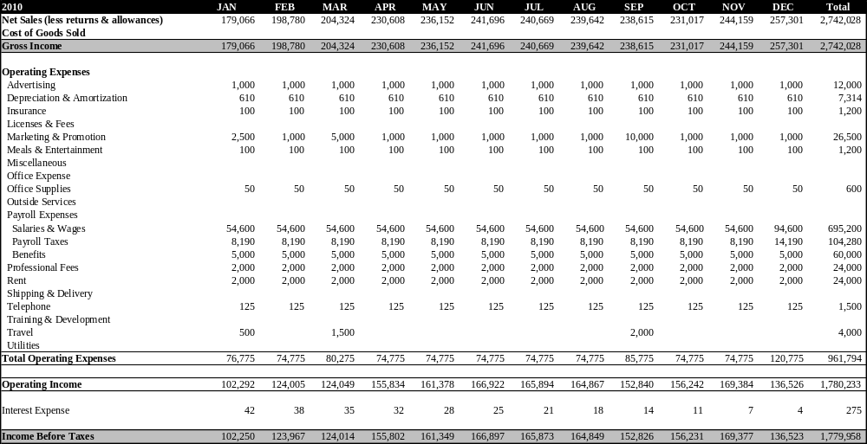

2008-2010 Annual Income Statements

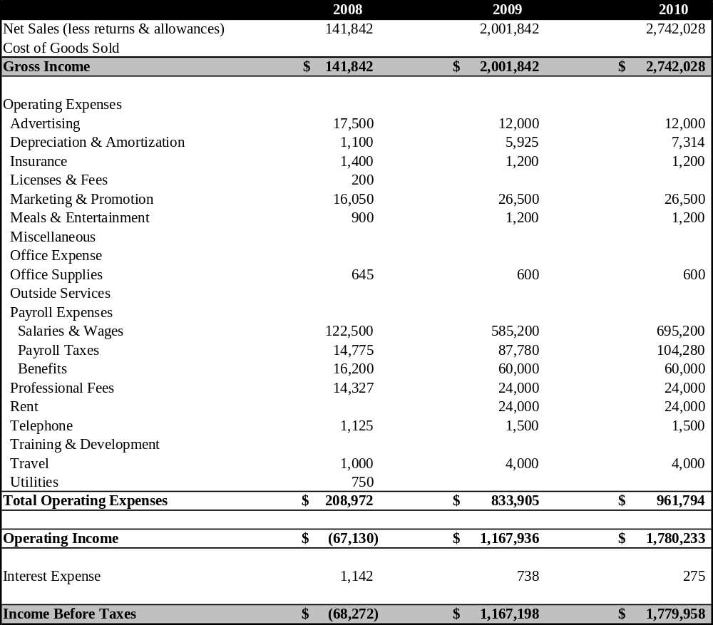
2008 Statement of Cash Flows

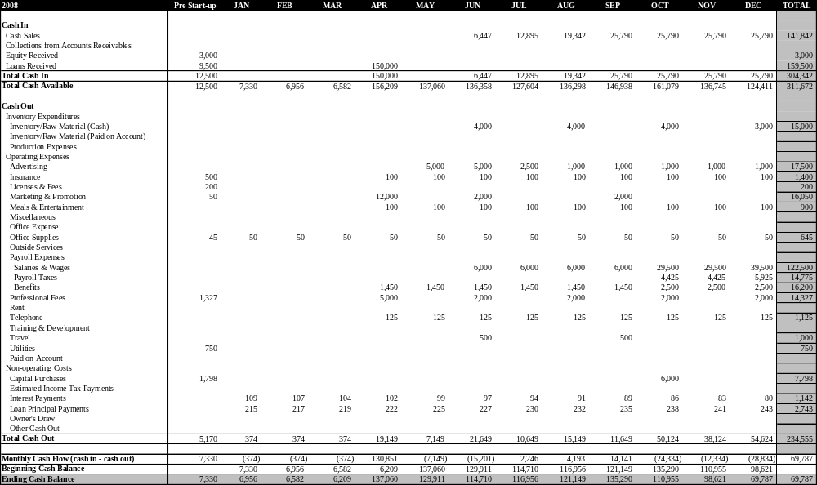
2009 Statement of Cash Flows


2010 Statement of Cash Flows


2008-2010 Annual Balance Sheets

